This document gives the screen shots of various options tested for defect Omiga00000056 (Vertex Ref 18) – issues while Zooming in Omiga application browser.

Fig. 1 shows the screen as we normally see, with no zooming on IE 7. Zooming is not an option in IE 6.

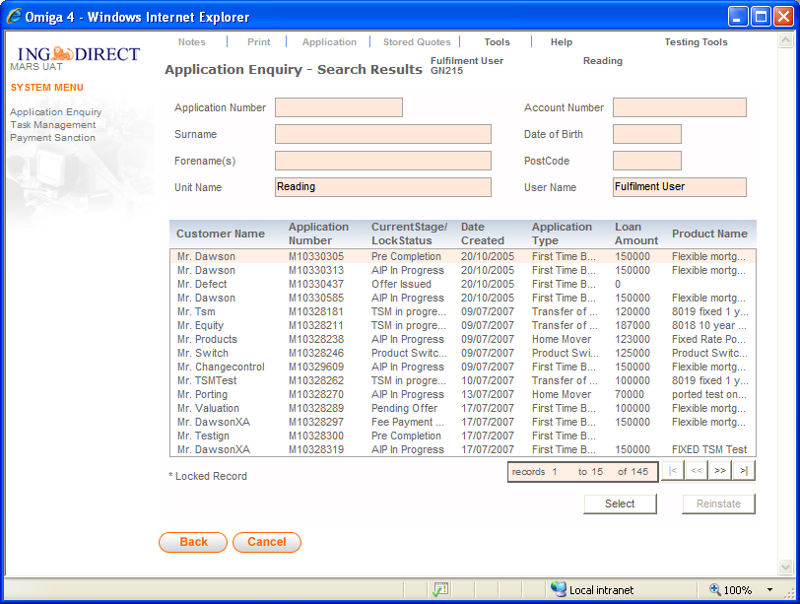 (Fig 1)

Zooming using mouse: Zoomed to 160% (Fig 2). The fonts are enlarged and the screen layout has adjusted appropriately. The entire screen could be seen without scrolling after maximizing the window’s size.
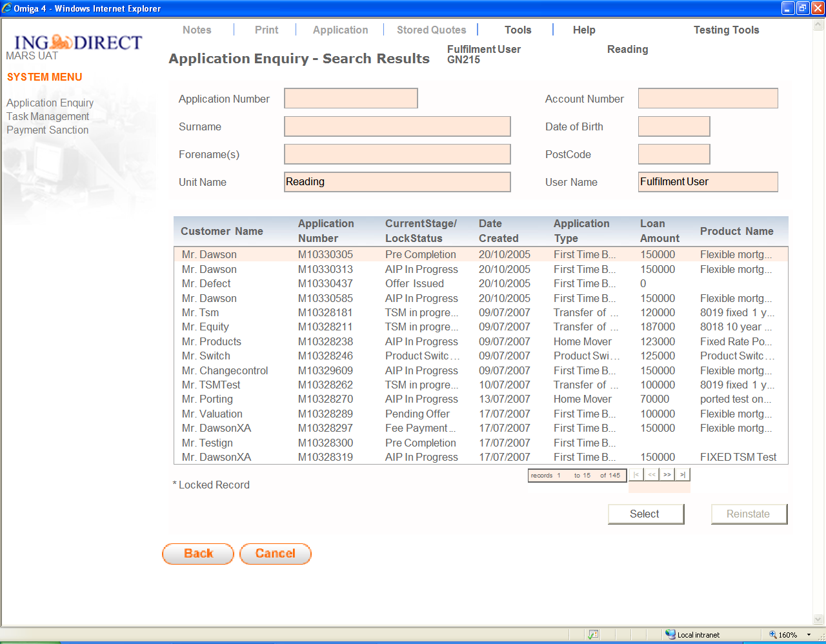 (Fig 2)
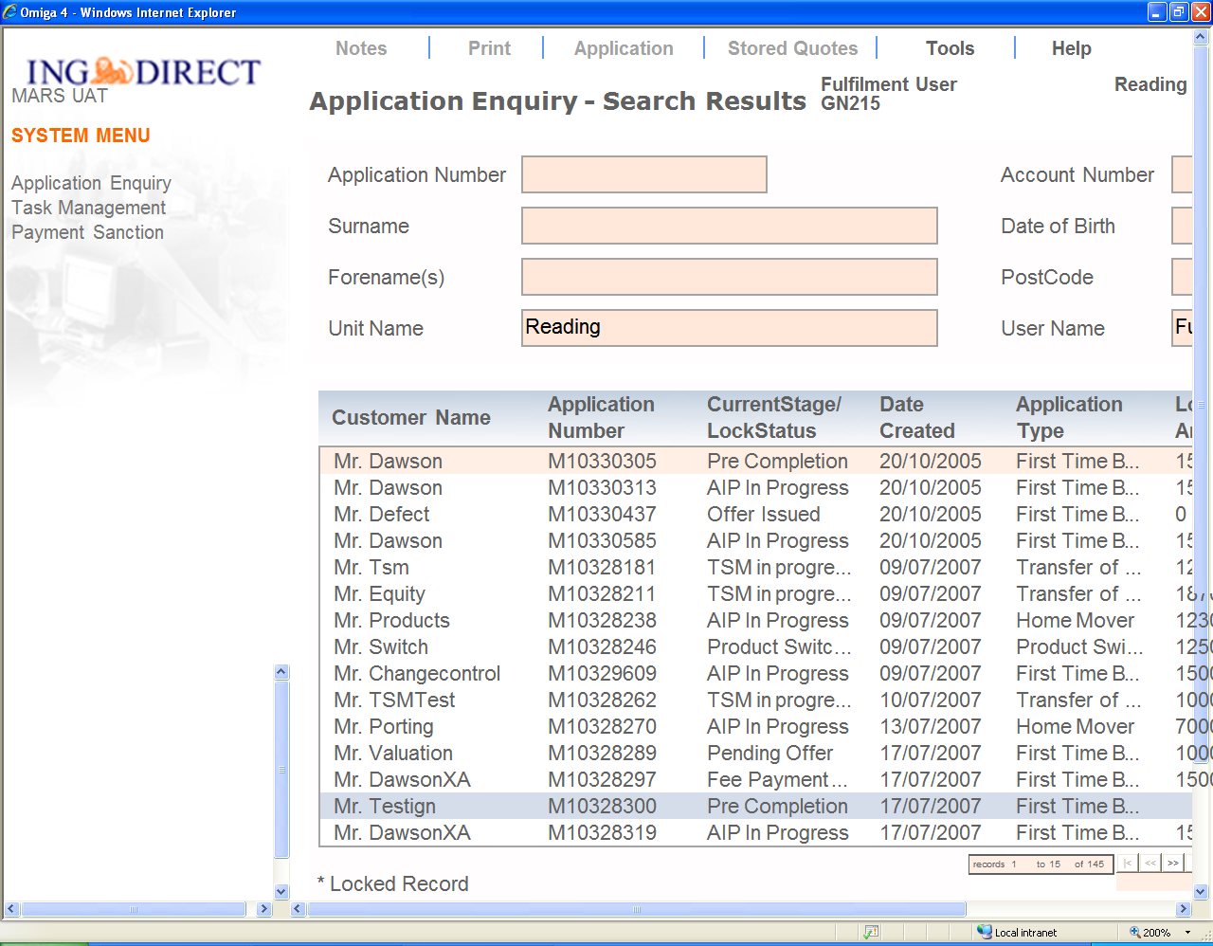 (Fig. 3)
Fig 3 is image of the same screen zoomed further (to 200%), where entire screen can not be viewed without scrolling to right and bottom. However by scrolling, the entire screen can be read.

While zooming-in, you would see some letters over the scroll bar (Fig. 3). This would disappear once the scroll bar is used to navigate across the window (Fig 4).
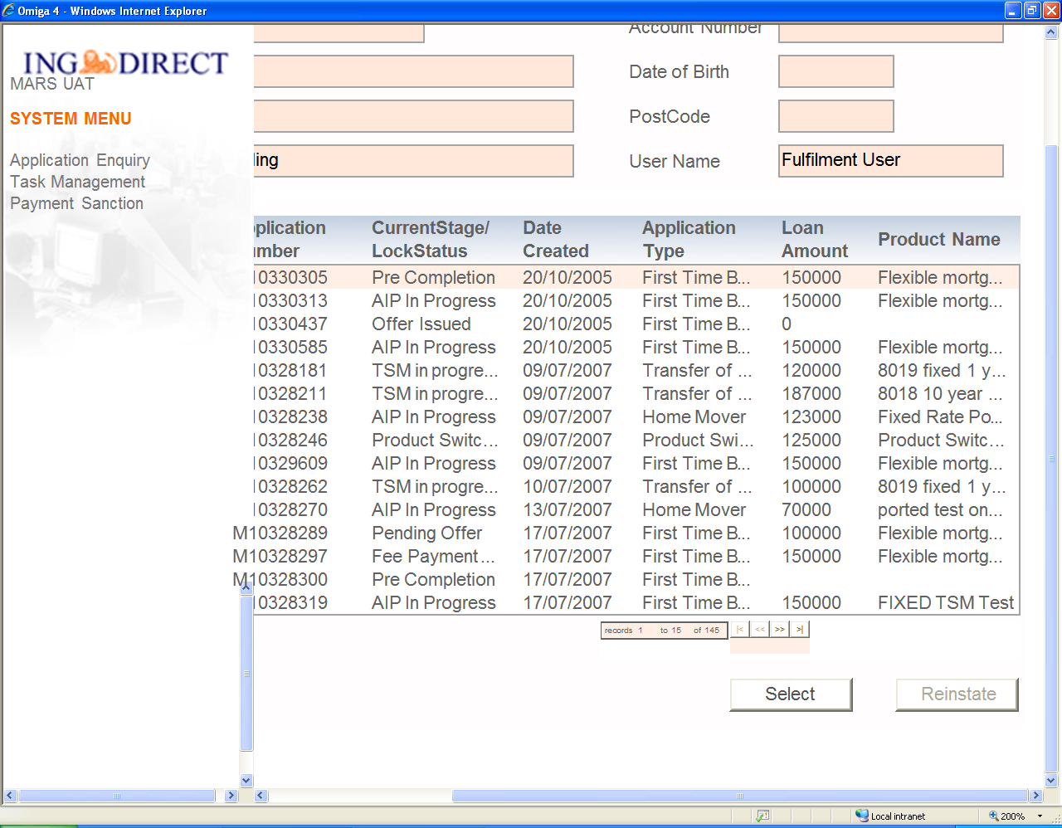 (Fig 4)
Screen Personal Details – zoomed to 170% (Fig. 5). The entire screen can be seen. The horizontal scroll bar is on. Though moving across you would find no information is hidden.

Fig. 6, the screen zoomed to 200%. Both the scroll bars appear and the entire information can be read by scrolling.
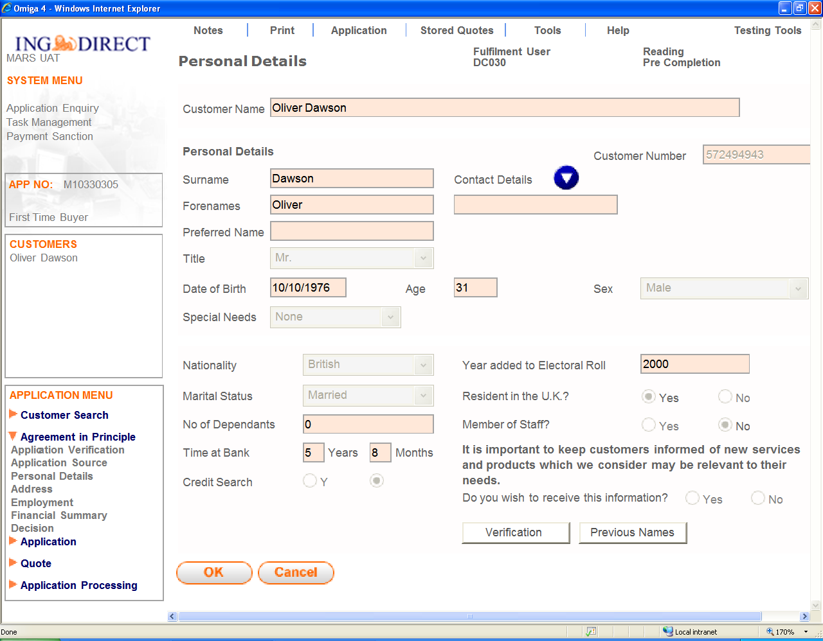 (Fig. 5)
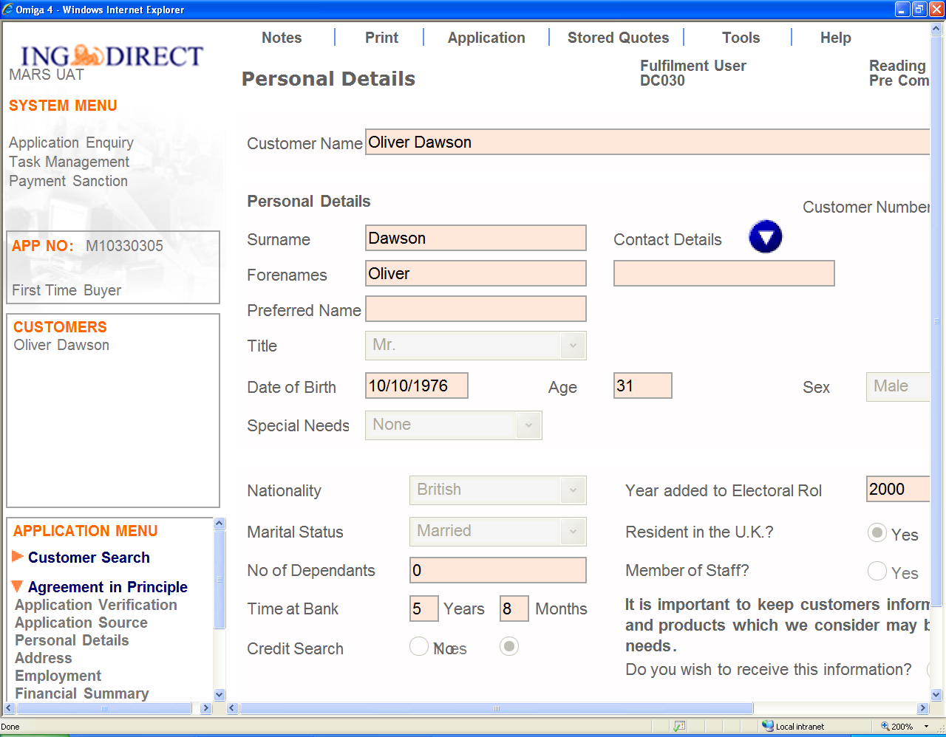 (Fig. 6)
Scrolling does not work on a pop-up window. Tried to zoom-in using mouse but doe not seem to have any affect (Fig. 8).

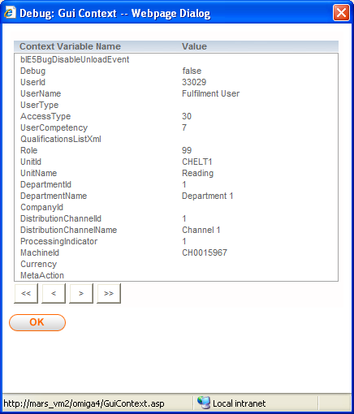 (Fig. 8)

